CN Lab 4
K225195 Laiba Fatima
Class Activity
Http Configuration
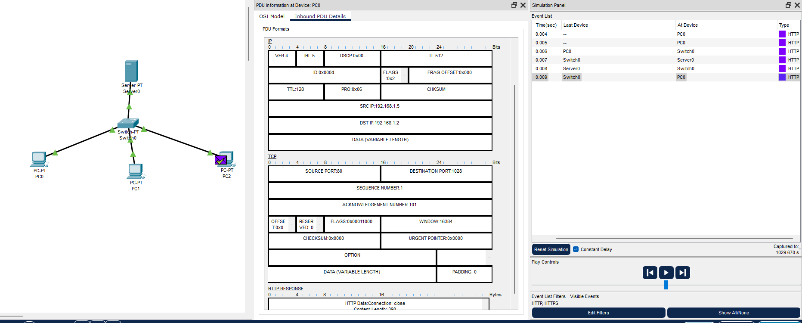
Https Configuration
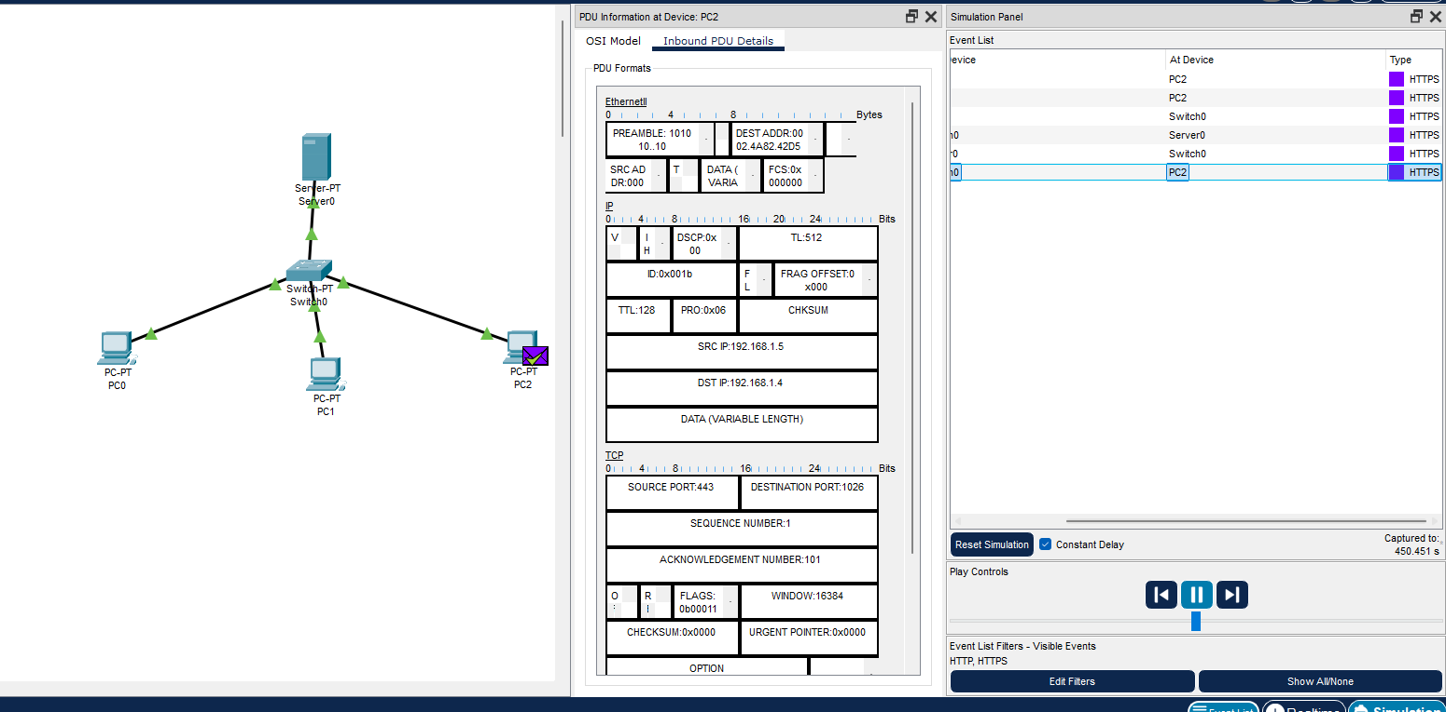
DNS Configuration
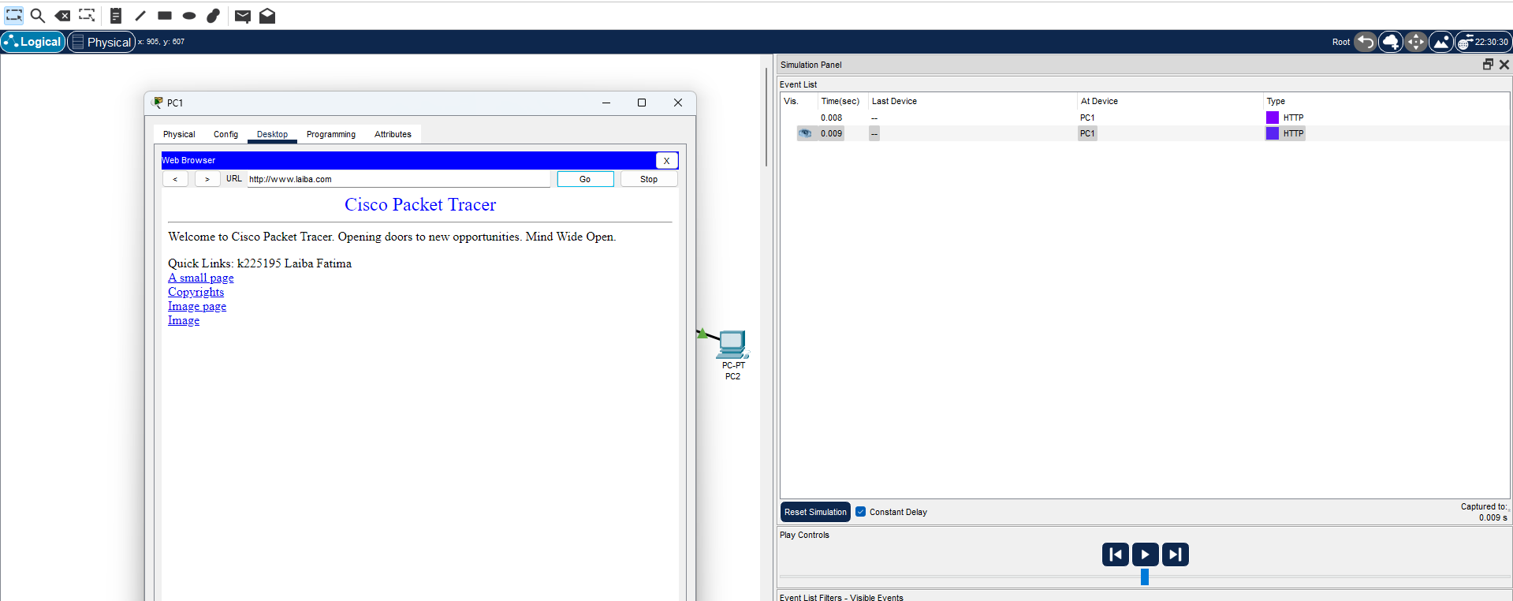
Alias configuration
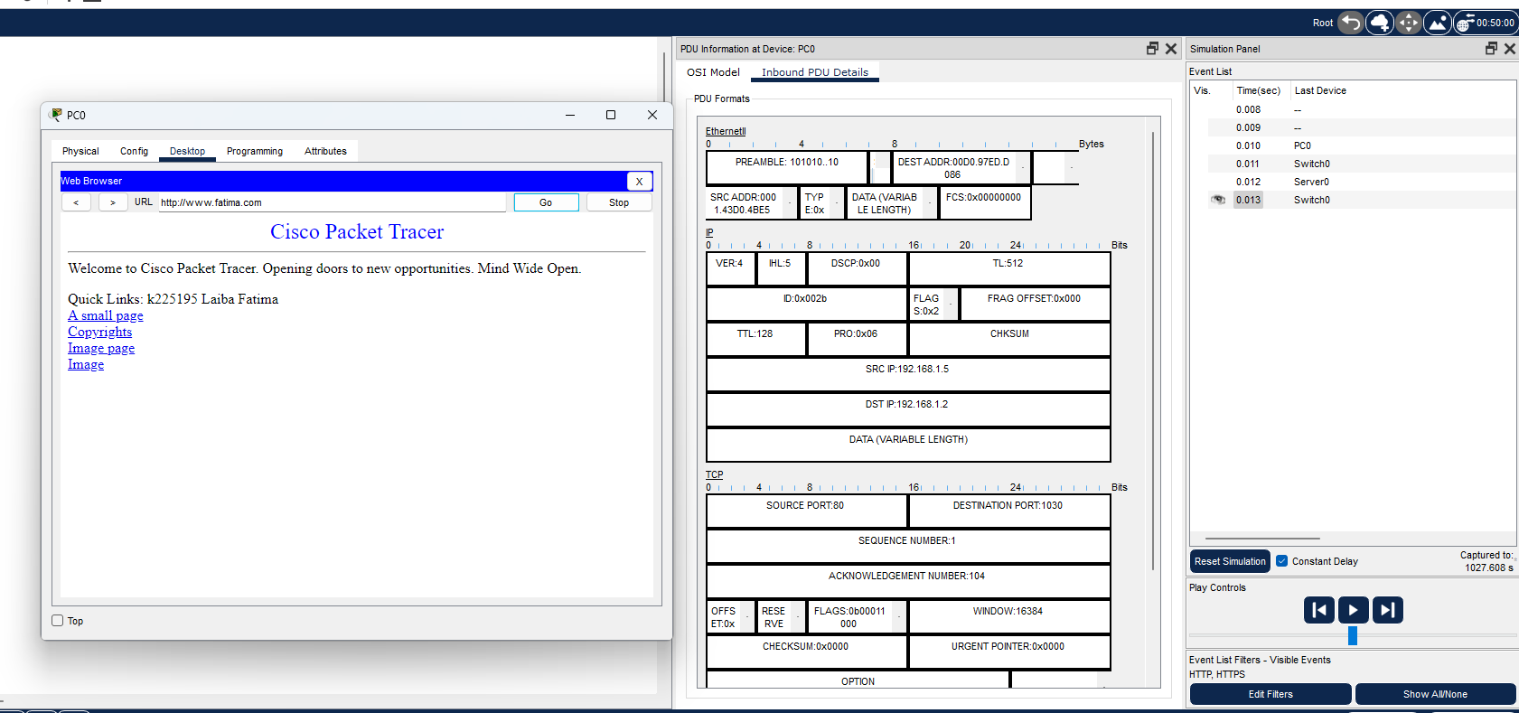
Router-Switch

Lab tasks
Task 1: Part 1
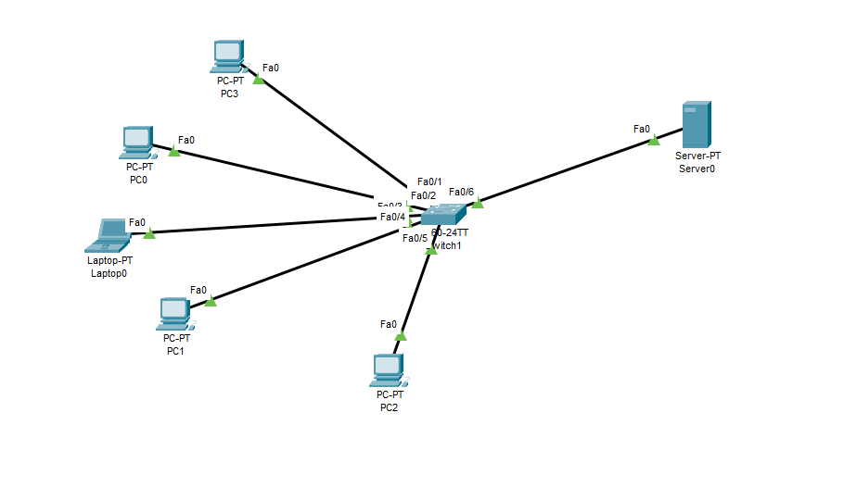
Task 1: Part 2

Task 2
1. The Age header represents the time since the response was fetched from the origin server by an intermediate cache. The Expires header specifies a fixed date/time after which the response is considered stale. Unlike Age, which is dynamically updated, Expires is a static timestamp set by the server.
2. General Headers: Apply to both requests and responses.
Request Headers: Sent by clients to provide additional request details.
Response Headers: Sent by the server with response metadata.
Entity Headers: Provide information about the body of the message.

Wireshark Tasks
Task 1
Https
- HTTPS Handshake: This shows how the client and server exchange certificates and establish a secure connection.

Task 2
Http
Difference in http and https is that in http we can clearly see the username and password, but in https it is filtered/secured
- HTTP vs HTTPS: HTTP data is visible in plain text, whereas HTTPS encrypts the data for security.

Bonus Task

